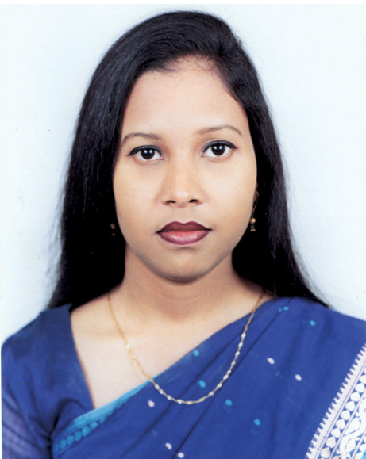 FLORA BAKUL

G.P.Cha-79/1, Mohakhali Gulshan
Dhaka-1212.
Mobile: 0172-1440674
E-mail Anisha990_0079@yahoo.com

PERSONAL PROFILE
A positive hard-working individual, who is self-motivated. I can work on my own, using initiative but also enjoy working as part of a team. My personal strengths include determination, flexibility and punctuality together with showing generosity and consideration to others. I am a kind, helpful person, and can explain my ideas clearly.

CAREER OBJECTIVE
I would like to work in such an open structured and steadily growing up organization having modern friendly environment where I will have got the career buildup opportunity.

KEY SKILLS
- Excellent communication and social skills
- Honest and trustworthy
- Excellent computer skills
- Organized and multilingual
- Can work as an Interpreter

PERSONAL INFORMATIONS

(A) Father’s Name : M. A. Bari
(B) Mother’s Name : Akter Zahan
(C) Date of Birth : 19, December 1981.
(D) Marital Status : Single.
(E) Nationality : Bangladeshi by Birth.
(F)Religion : Islam (Sunni).
(G) Present Address : G. P. Cha – 79/1 Mohakhali Wireless gate, Gulshan, Dhaka-1212,
(H) Permanent Address : Same as above.

(H) EDUCATION

Name of Exam | Division/class/CGPA | Board/University | Year of Passing
B.Sc. in Computer Science | 1st | Asian university of Bangladesh | 2003
Higher Secondary | 2nd | Dhaka | 1998
Secondary School | 1st | Dhaka | 1996

TRAININGS/ COURSES

- Under Graduate Project work database and on payroll system by using Oracle 8I and Visual Basic under supervision of Mr. Khondokar Zahidur Rahman, Chairman of R.M. Sweater company.
- Accounting Management System by using Microsoft SQL and Visual Basic in Kazi International Construction Ltd. Banani, Dhaka-1213.

(I) Experience

1ST January, 2007 – Till {PRESTON UNIVERSITY}
{Front desk officer / Admin}
{Banani, Dhaka}.

COUNCILOR/ ADMIN

- Working as Front desk officer and Admin also.
- Deal with student and giving support of them.

1st April 2005 – December 2006 {Vinci Networks},
{ISP}.
{ Private Assistant }
PRIVATE SECRETARY TO MD

- It’s a position personal assistant to Chairperson, Receiving Phone calls, Taking message, Coordination.
- Organize & maintain Chairperson’s office so that day to day office functioning of Chairperson’s Secretariat runs smoothly.
- Coordinate with individuals & fix appointment after getting it confirmed from Chairperson. Maintain Appointment Diary of Chairperson and remind him accordingly.
- Arrangements of meeting & attend various meetings of Chairperson.
- Look after Safety & Security aspects of Chairperson in & outside office.
- Check up Visa expiry date of important countries in Chairperson, Director & Other Official’s passport & arrange timely renewal. Know detailed procedure & visit different offices of foreign missions for such renewal.
- Organize Lunch / Dinner for Mr. Chairperson with important buyers / dignitaries in Hotels or at office of Chairperson. Keep telephone number and address of important hotel & restaurant for this purpose accordingly.
- Keep records of important visitors.
- Check mail and fax of Chairperson& receive all types of incoming letters & go through minutely for the next course of action and present it timely to Chairperson.
- Ensure all relevant documents & records given by Chairperson are passed on to the relevant department / individuals timely & regularly.

5th Nov 2003 – 15th March 2005 {Kazi International Construction Ltd}.
{Computer Department}
{Banani, Dhaka}
COMPUTER ENGINEER

- Working as Network Administrator for 5 workstation.
- Maintenance and troubleshot PCs.
- Deal with Customer request and give support of them.
- Monitoring and updating Antivirus Software.

LANGUAGE PROFICIENCY

Language Reading Writing Speaking

English Good Good Good
Hindi Good Good Good
Bengali High High High

INTEREST AND HOBBIES

I have an interest in Photography and Editing side also. To relax I enjoy reading, listing to music and watching movies. I like visiting people and helping disable child.

Signature
(Flora Bakul)

